**Setup Hadoop on Windows 11**

1. Download Java SDK, JRE and **Hadoop 4.2.4** from <https://drive.google.com/drive/folders/11nMEChq2-kCsOsyW51Y4n11j-zAH9Be5?usp=sharing>
2. Unzip **Hadoop 3.2.4** Setup file
3. Extract **hadoop.rar** to C drive, **C:\hadoop**
4. Install Java SDK and JRE
5. Create Environment Variables for **JAVA_HOME** & **HADOOP_HOME**

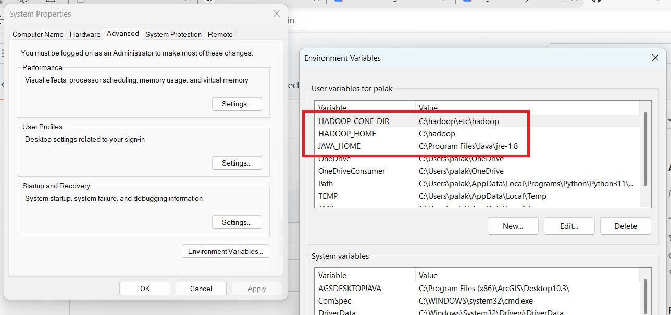

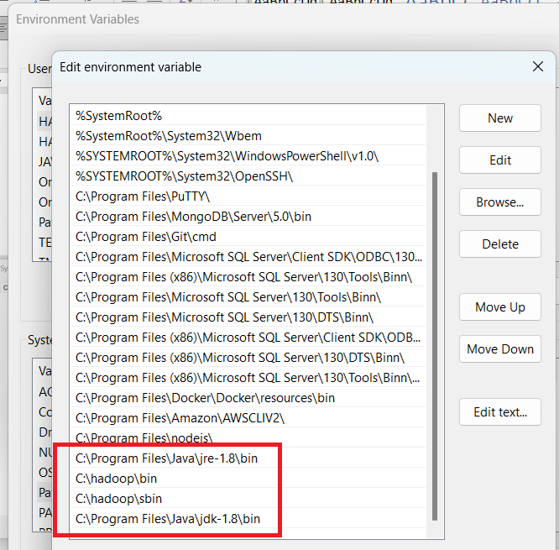

1. Run Command Prompt as Administrator
2. Launch Hadoop Cluster
   1. hdfs namenode -format
   2. start-all.cmd
3. Open Browser and Launch below sites for

* Name node web page: <http://localhost:9870/dfshealth.html>
* Data node web page: <http://localhost:9864/datanode.html>
* Yarn web page: <http://localhost:8088/cluster>